Table of Contents
Business case 2
1.1 Pool Maintenance in Disarray 2
1.2 Project Objectives 2
For the Individual Pool Owner 2
For the Pool Service Business 3
1.3 Problem Background 3
1.4 Related Systems Analysis 6
Orenda 6
Pool Chemical Calculator 7
Pool Math 9
1.5 The Project Plan 10
What we are delivering 11
How we will deliver 11
Milestones & Deliverables 12
Stakeholders 13
1.6 Risk Analysis 15
1.7 Annexure 17
1.8 References 18

Business case

This document serves as a comprehensive business case for our proposed project, SplashScreen, a localized mobile application created to simplify swimming pool maintenance in South Africa. As we structured this document, we kept the principles of the Software Development Life Cycle in mind. As a result, this business case is segmented into three key primary sections: a detailed look at the problem, a concrete analysis of our solution, and a strategic plan for the execution.

Through providing verified references, a thorough risk analysis, and a systematic project roadmap, we, The Ripple Effect, aim to give all our stakeholders the information needed to support the development and implementation of SplashScreen. This is our foundational blueprint, justifying the project's viability and demonstrating a clear path forward.

1.1 Pool Maintenance in Disarray

In South Africa, pool ownership is quite popular due to the country’s warm climate, yet pool maintenance remains a challenge for both private homeowners and commercial facilities such as hotels and estates. The real-world problem lies in the inconsistent and often unreliable maintenance practices that result in unhygienic water, damaged equipment and costly repairs. Many clients struggle with keeping track of maintenance schedules, chemical usage and service provider accountability, while pool maintenance companies face difficulties in managing multiple clients, coordinating staff and ensuring service quality.

This problem has always existed within the pool care and maintenance industry, where the demand for clean, safe and functional swimming pools is high, but communication gaps, lack of transparency and poor record-keeping lead to inefficiencies and customer dissatisfaction, prompting an urgent need for a structured, technology-driven solution that can improve service delivery, build trust, and streamline workflow.

1.2 Project Objectives

At its core, SplashScreen is designed to be a meaningful intervention in the lives of South African pool owners and the dedicated professionals who serve them. The primary goal of managing pools more effectively can be dissected into multiple, specific sub-problems. Each sub-problem is then addressed by a specified respective system objective.

For the Individual Pool Owner

Problem: The constant struggle with uneducated pool care often leads to wasting resources. This comes from a lack of personalized pool care guidance.

Objective: SplashScreen should equip pool owners with easy-to-follow, personalized guides and an accurate water chemistry calculator that reduces maintenance complexity.

Problem: Manual record-keeping is time-consuming and often leads to frustrating pool management.

Objective: The app should save pool owners time, not only just digitalizing pool care but also providing proactive, automated notifications for essential maintenance tasks and potential issues.

Problem: It is difficult finding a trusted service provider for pool management. Even when found, handling updates between the service provider and the pool owner is often decentralized.

Objective: Simplify the process of hiring professionals by connecting our app users with a network of vetted, local service providers, making it easy to book services and find the right products with just a few taps.

For the Pool Service Business:

Problem: There is a lack of modern, centralized tools to efficiently manage clients, jobs, and business operations which often holds back business growth.

Objective: Equip our local pool service providers with comprehensive digital tools for job management, allowing them to streamline their operations, save time, and focus on providing excellent service.

Problem: Reaching new clients professionally and building a professional brand in a competitive, fragmented market is challenging for small local service providers.

Objective: Provide a powerful, searchable platform that acts as a digital storefront for businesses, helping them attract new customers and grow their reputation through a system of verified bookings and customer reviews.

1.3 Problem Background

South Africa is a water-scarce country. National and international climate datasets describe South Africa as semi-dry with an average annual rainfall of roughly 464 mm, almost half the global average, a structural constraint that heightens drought risk and pressures domestic water use. (Wold Bank Group, 2021) Research in Cape Town reveals that household water use is highly unequal, with the wealthiest +/-14% of residents consuming over half of the municipal water, much of it for non-essential purposes such as filling pools and irrigating gardens. (Savelli, 2023)
Private swimming pools use a lot of water in South African suburbs. There are an estimated 800,000 private pools in the country, which is high compared to other places. This figure comes from marketing sources but matches older engineering estimates of about 700,000 pool pumps in use in 2010. (Econsultancy, 2022) (bigEE, 2015)
Studies in Cape Town confirm that homes with pools use more water, based on research across thousands of households. (Musango & Peter, 2012) (Du Plessis & Jacobs, 2015)
In South African metros, municipal restrictions during droughts often target discretionary uses. For example, the City of Cape Town’s restrictions historically required non-permeable covers for topping up and limited filling from municipal supply, reflecting policy levers that directly affect pool owners and service providers. Water scarcity policies further complicate maintenance. Many municipalities impose restrictions on topping up pools, particularly during droughts, limiting owners’ ability to dilute concentrated chemicals or replace evaporated water. (Department of Water and Sanitation, 2023) Not being able to adhere to these regulations not only wastes water but can also lead to financial penalties or fines.
Unreliable electricity is a challenge in South Africa. Load shedding interrupts pool pump schedules, which affects water circulation and disinfection. This can cause algae to grow and strain equipment when the power comes back. Pool pumps also use a lot of electricity. Each pump uses about 2,600 kWh per year, adding up to around 1.84 TWh nationwide. (bigEE, 2015). Making pumps more efficient can save money and ease pressure on the power grid. Load shedding also reduces chemical distribution, allowing contaminants to accumulate. If pumps are not restarted promptly or properly after power is restored, water quality deteriorates, increasing the risk of pathogen growth such as E. coli and Cryptosporidium, which are harmful to swimmers. (Queensland Government, 2019)
The health and safety dimension requires a disciplined approach to water chemistry. International public-health guidance, used globally by operators and many residential guides, recommends maintaining free chlorine at 1-2+ ppm depending on cyanuric acid and pH between 7.0-7.8 to control pathogens and protect bathers and equipment, reinforcing the value of guided testing, calculators, and reminders for non-expert users. (CDC, 2024)
New pool owners are often surprised by how technical pool maintenance can be. To keep water safe, you need to check pH, chlorine, alkalinity, and calcium hardness regularly. These steps help stop germs from spreading, protect your equipment, and keep swimming safe. For instance, if the pH is not between 7.2 and 7.8, chlorine is less effective, algae can grow, and pumps or metal parts might corrode. (CDC, 2024)
Most pool owners find it hard to figure out how much of each chemical to use, especially if their pool size changes or they add water often. Small mistakes, like missing a chlorine dose or not checking pH, can quickly turn into bigger problems. Algae is an obvious sign of poor maintenance. It makes the water green and cloudy, clogs filters, requires more cleaning, and can even damage pool surface over time.

Not knowing enough about pool care can also lead to equipment damage and extra costs. Using too much chlorine can corrode pumps, heaters, and liners. Too little chlorine lets algae and bacteria grow, which means you might need more chemicals or professional help. These problems show that poor pool maintenance can waste water, increase costs, create safety risks, and damage pools. That’s why clear guidance and simple maintenance systems matter.
In South Africa, pool maintenance usually happens in two ways. Homeowners do it themselves or hire professionals. Both options depend on getting the right chemicals, equipment, and services like cleaning or repairs. But the market for these products and services is very scattered.
Homeowners often struggle to find reliable suppliers or service providers. There are company websites, Facebook Marketplace, local directories, and small business apps, but these are all separate, so people have to search and check providers themselves. There is not much transparency, prices vary, and it’s hard to know if the service will be good.
As illustrated in the project proposal, the core problem isn't a scarcity of pool maintenance services, but the inefficiency created by a decentralized market. In South Africa, there isn’t one platform that covers everything, from DIY water testing and advice to booking trusted service providers. A digital, all-in-one solution would help homeowners track chemical levels, plan maintenance, and book professionals easily. For businesses, it would provide a clear marketplace, help them find more customers, and make managing work and supplies simpler.
By combining these elements, such a system could address multiple local challenges simultaneously, including reducing water and chemical waste, lowering operational costs, improving compliance with municipal regulations, and ensuring consistent, reliable service. This aligns with global trends in digital service marketplaces, which demonstrate that centralized platforms improve both user experience and business efficiency (Lee & Kim, 2019) (Patel, Mehta, & Sharma, 2021)

1.4 Related Systems Analysis

Orenda

Platforms: Web, Android, iOS
Description: Orenda is a professional-grade water chemistry calculator and educational platform. It is designed to empower pool service professionals and serious DIY enthusiasts with precise chemical dosing and a deeper understanding of water balance. The system focuses heavily on the “Orenda startup process” and specific water management principles. It is a tool for more experienced professionals, not a general consumer app.

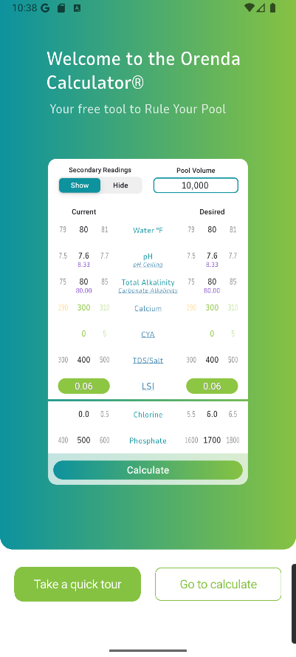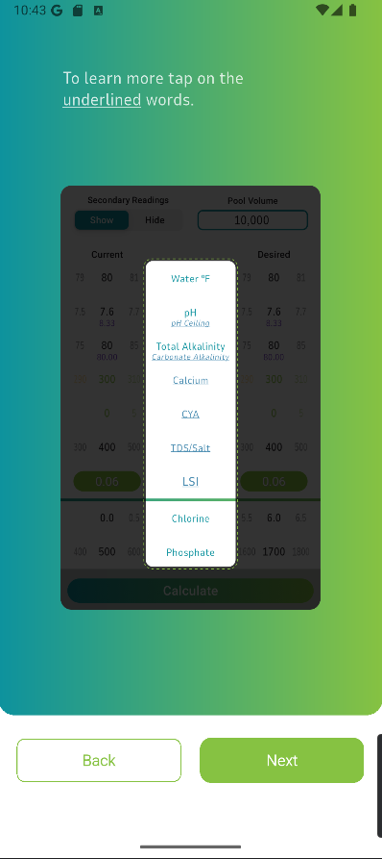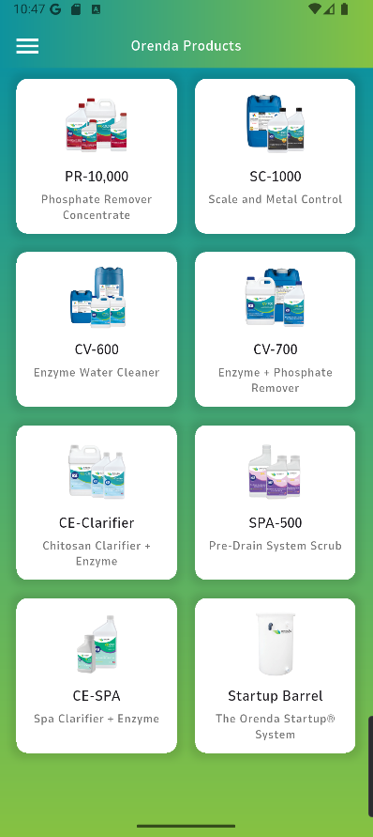

Figure 1.1 Figure 1.2 Figure 1.3

Features to Adapt:

Scientific Accuracy: As visible in Figure 1.1, the core of Orenda's value is its scientific ability. This chemical calculator provides a highly detailed system that allows users to check their pool specifications against a well-tested system. We should adapt its focus on precise chemical calculations and correct water balance principles. SplashScreen's water chemistry calculator must be scientifically sound and highly reliable.

Educational Content: Orenda’s user support is high. When logging in to the application for the first time, users are introduced to how the chemical calculator works, Figure 1.2. In addition to this, there is also a dedicated panel for searchable educational content, under “Orenda Procedures”. User help and support is an important factor in the feasibility of our project. We should incorporate a feature that educates users on the "why" behind their maintenance tasks, building their knowledge and confidence over time.

Targeted Dosing: The system provides precise dosing recommendations based on pool volume and chemical readings. We can include this in our application and extend it to be more functional for other metrics.

Features to Avoid:

Exclusivity: The main issue we identified with Orenda is that it is extremely focused on the company’s specific chemical product line, not offering alternatives at better price ranges. Figure 1.3 illustrates products only offered by Orenda. This exclusivity is also extended through the professional-centric language that be complicated to understand. Our system should avoid brand exclusivity and use language that is accessible to the average pool owner.

Lack of Proactive Features: Orenda is a manual calculator that requires constant user input. While SplashScreen will adapt this model, we will extend it with our proposed proactive features such as load shedding alerts, municipality restriction check, and weather-based predictions.

Lack of Business Model: As mentioned previously, Orenda is solely built for the Orenda enterprise. This architecture lacks our proposed marketplace, where users can interact with business profiles, services and products.

Reference: Orenda. (n.d.). Orenda App. Retrieved from https://www.orendatech.com/app

Pool Chemical Calculator

Platform: Android, iOS
Description: Pool Chemical Calculator is a well-known hybrid system that serves both individual pool owners and small maintenance businesses. It provides a comprehensive set of tools for calculating chemical dosages, tracking multiple pools, and even planning service routes. The app is highly functional but can feel cluttered due to its broad range of features. It aims to be an all-in-one tool for pool management.

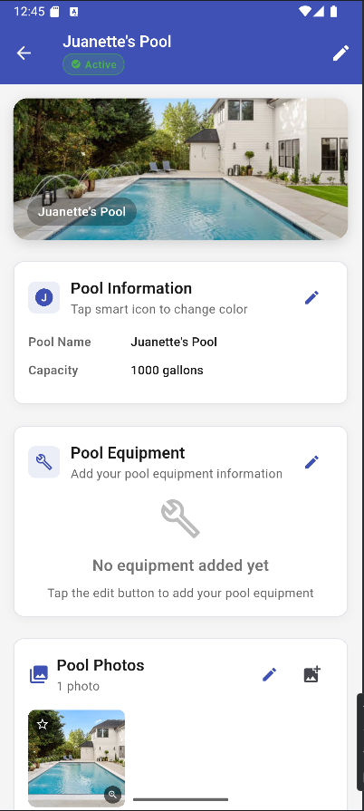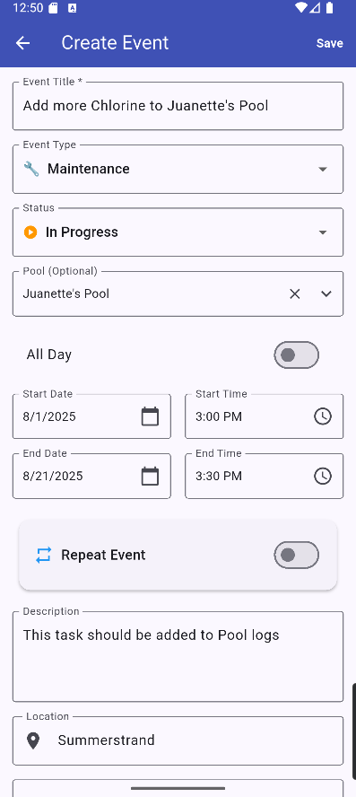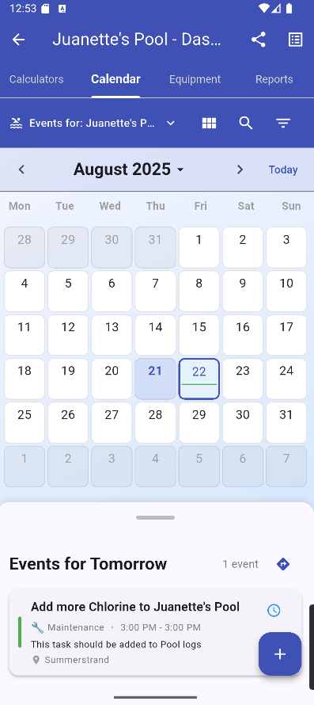
Figure 2.1 Figure 2.2 Figure 2.3

Features to Adapt:

Multi-Pool Management: The ability to add and manage multiple pools is crucial for both our pool individuals and service providers. Figure 2.1 showcases Pool Chemical Calculator’s multi-pool management system, equipped with tracking for different parameters. We will adapt this feature to allow users to track their home pool, a second property, or even a small portfolio of client pools for local service providers.

Task Management: The system has a robust task list and reminders through a built in Calendar system. Figure 2.2 demonstrates the procedure of creating an event also represented as tasks. Once complete, these are added to the respective pool’s calendar dashboard, Figure 2.3. We will incorporate a similar feature for scheduling and tracking maintenance tasks, extending our app’s maintenance capabilities.

Hybrid User Model: This app proves that a single platform can effectively serve both individuals and professionals. Pool management is universal for both individuals and businesses while there are unique features such as route tracking for pool location made solely for service providers. As SplashScreen incorporates both user types, adapting this approach by offering distinct but integrated user experiences for our B2C and B2B users will support our marketplace model.

Features to Avoid:

User Interface Clutter: The app's wide range of features can make the UI feel busy and overwhelming for a new user. We must avoid this by designing a clean interface that is easy to navigate.

Lack of Specialization: By trying to do everything, the Pool Chemical Calculator doesn't excel in a single area. We must avoid this by making our core features, such as chemical tracking, load shedding alerts, and marketplace integration highly polished.

Reference: Pool Chemical Calculator. (n.d.). Pool Chemical Calculator App. Retrieved from https://poolcalculator.com/

Pool Math

Platform: Web, Android, iOS
Description: This app, created by the highly respected Trouble-Free Pool (TFP) community, is considered the go-to app for DIY pool owners. It's an advanced and free-to-use chemical calculator that gives incredibly accurate dosing instructions based on the user's specific pool volume and readings. It's built on a very specific and popular methodology, which makes it a trusted source for millions of pool owners worldwide.

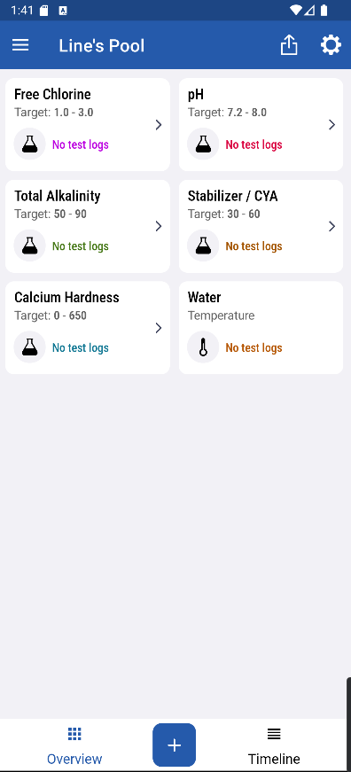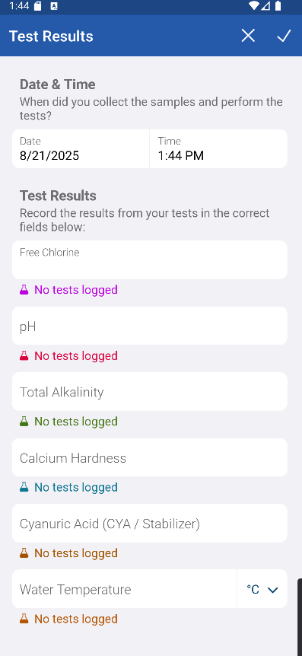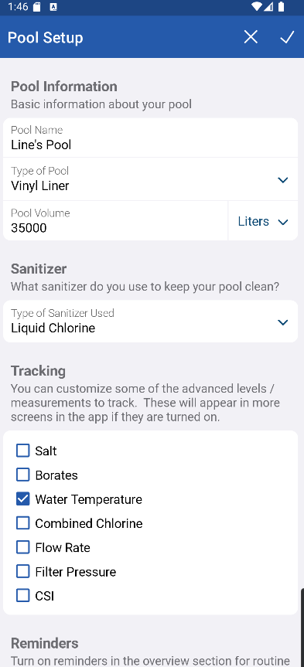
Figure 3.1 Figure 3.2 Figure 3.3

Features to Adapt:

Scientific Accuracy and Trust: The main feature we have identified from PoolMath is that accuracy builds trust. Its calculator is simple but flawless. Once again as stated in our analysis of Orenda, the core chemical calculation functionality of SplashScreen must be reliable to earn our app users' trust. All 3 Figures demonstrated the capabilities of PoolMath.

Simple, Focused UI: The app's interface isn't fancy, but it gets the job done without any distractions. Figure 3.1 shows us the simple central card stack for different calculations while Figure 3.2 is the test results in action. Evidently, this proves that while a modern UI is a requirement, a complex one isn’t. As The Ripple Effect, we strive to build a similarly intuitive and clean user experience.

Community Integration: While not built into the app itself, Pool Math's success is tied to the TFP online community. We identified this as a strong factor in our Software Development Life Cycle as a knowledgeable support base will drive the feasibility of this project.

Features to Avoid:

A Manual-Only System: Pool Math is a pure calculator. It doesn't offer any proactive features like push notifications, load shedding alerts, or weather-based predictions. SplashScreen shouldn’t share its passive nature but be an app that actively helps the user.

Lack of a Marketplace: PoolMath has no business model. It's simply a tool. Our app, by contrast, must solve the problem of finding local service providers and products. PoolMath's singular focus on DIY is a flaw from a business perspective, and SplashScreen’s hybrid model directly addresses this.

Reference: Pool Math. (n.d.). Pool Math App. Retrieved from https://poolmath.com/

1.5 The Project Plan

The Ripple Effect
Project Name: SplashScreen
Client Name: Swimpool Centre
Delivery Date: 1st November 2025

The main goal of SplashScreen is to produce a simplified pool maintenance workflow. The Ripple Effect, consisting of Liné Redpath, Juanette Viljoen and Tinotenda Mhedziso, has constructed the following project plan that breaks down our strategic plan at achieving this objective.

What we are delivering

As expanded upon in section 1.1, our solution, SplashScreen is a mobile application that serves as a single platform for pool management. We have chosen to build this type of application as it has presented to be the most accessible to our target market: pool owners and pool service providers. The core deliverable is a functional prototype of our system that helps individual pool owners manage their pool's pH, chlorine levels, and equipment maintenance. For pool maintenance businesses, our minimum viable product (mvp) will provide tools to manage their schedules, clients, and staff. In addition to this, we will also include localized weather tracking and marketplace for pool care products and services.

How we will deliver

We have adapted an agile, Scrum-based approach with bi-weekly sprints based on our project’s documentation and development phases aligning with module requirements.
To complete these sprints, we will hold weekly team stand-ups to share progress and discuss challenges. For client feedback and review, we will conduct bi-weekly reviews with the Swimpool Centre team and collect responses via Google Forms. Our project development is facilitated through GitHub and project management is achieved through ZenHub, a free, open-source GitHub integration.
Figure 4.1 illustrates the ZenHub timeline feature, similar to a Gantt chart, that we have used to map our workflow. Each sprint, completes a specific portion of the project requirements such as the Business case. Within each sprint, we are tracking individual tasks with assigned start and end dates. The progress bar (e.g., 5/15) provides a clear, at-a-glance view of the team's progress, showing the number of completed tasks against the total for each sprint.

Our team has a history of successful projects specified below:

CheckIT
Platform: Android
Description: A full-stack Android app using Java and SQLite that facilitates task management between instructors and students, with role-based access for admins, instructors, and students.
Project Link: https://github.com/Passion-Over-Pain/CheckIT

Download Link: https://github.com/Passion-Over-Pain/CheckIT/releases/download/v1.0/CheckIT.apk

Project Management Web App
Platform: Web
Description: As part of this project, we developed an IT Project Management web application designed to streamline the process of assigning and tracking tasks for a project team.
Project Link: https://github.com/Passion-Over-Pain/ProjectManagementApp-Assignment
These projects did not come without their own challenges and we have identified both the risks we have previously faced and how to mitigate them effectively:
Limited Time: As we are a dynamic team with different sets of responsibilities, we have often faced We are mitigating this by starting our project iterations earlier.

Limited Resources: As an unfunded project, we are limited to digital resources. We have moved from ClickUp to ZenHub ensure access to a crucial Gantt chart view for our workflow.

High Project Complexity: In the past we have experienced issues with highly complex projects that were out of the scope of the proposed solution. This often came from being too ambitious in documentation and development, which in turn was detrimental to our execution cycle. We have decided to maintain a lean approach with SplashScreen, meaning we are adapting the necessary minimal features required to solve the problem, pool maintenance, first then iterating over this to ensure refinement. After this then we will expand our catalogue.

Milestones & Deliverables

Our project milestones are segmented into three main parts, each with specific deliverables:
- Part 1: Documentation

- Deliverables: Project Proposal, Business Case, System Requirements, Specifications, and Technical Design.

- Part 2: Implementation & Development

- Deliverables: Backend, frontend, and design of the application.

- Part 3: Finalization & Submission

- Deliverables: Final bug fixes, design improvements, and the final presentation of our system.

Stakeholders

- Client: Our end users are the primary audience and critical stakeholders whose needs and feedback will shape the system's usability and features. While we have the Swimpool Centre team for the business model review, we are also approaching potential individuals for the DIY model.

- Reference Business: Swimpool centre, our reference for the business model, will clarify details about their services, products, and processes to ensure accurate representation within the app.

- Project Sponsor: Nelson Mandela University has provided us with the project structure, template plan and computing resources to execute this project.

- Project Team: The Ripple Effect team consist of:

- Database and Systems Designer: Liné Redpath
Liné is responsible for designing the system's architecture and database schema, ensuring a solid, scalable foundation for the application.

- UI/UX Designer: Juanette Viljoen
Juanette focuses on the user interface and user experience, creating wireframes, mockups, and prototypes to ensure the app is intuitive, accessible, and visually appealing for both pool owners and service providers.

- Project manager and Software Developer: Tinotenda Mhedziso
Tinotenda oversees project coordination and is responsible for writing the backend code that powers the application's core functionality and integrations.

Evidently as seen from Figure 4.2, some tasks are not exclusive to the team member role rather most tasks depend on others to be complete thus using the sprint approach, Figure 4.1, we also introduce dependencies in the form of sub-tasks. This cross-functional approach ensures our team is adaptable and productive, a core tenet of the agile development methodology we've adopted.

- Project Supervisor: Vuyolwethu Mdunyelwa serves as SplashScreen’s project supervisor, an important stakeholder who ensures academic compliance, provides guidance, and is responsible for marking and grading our project.

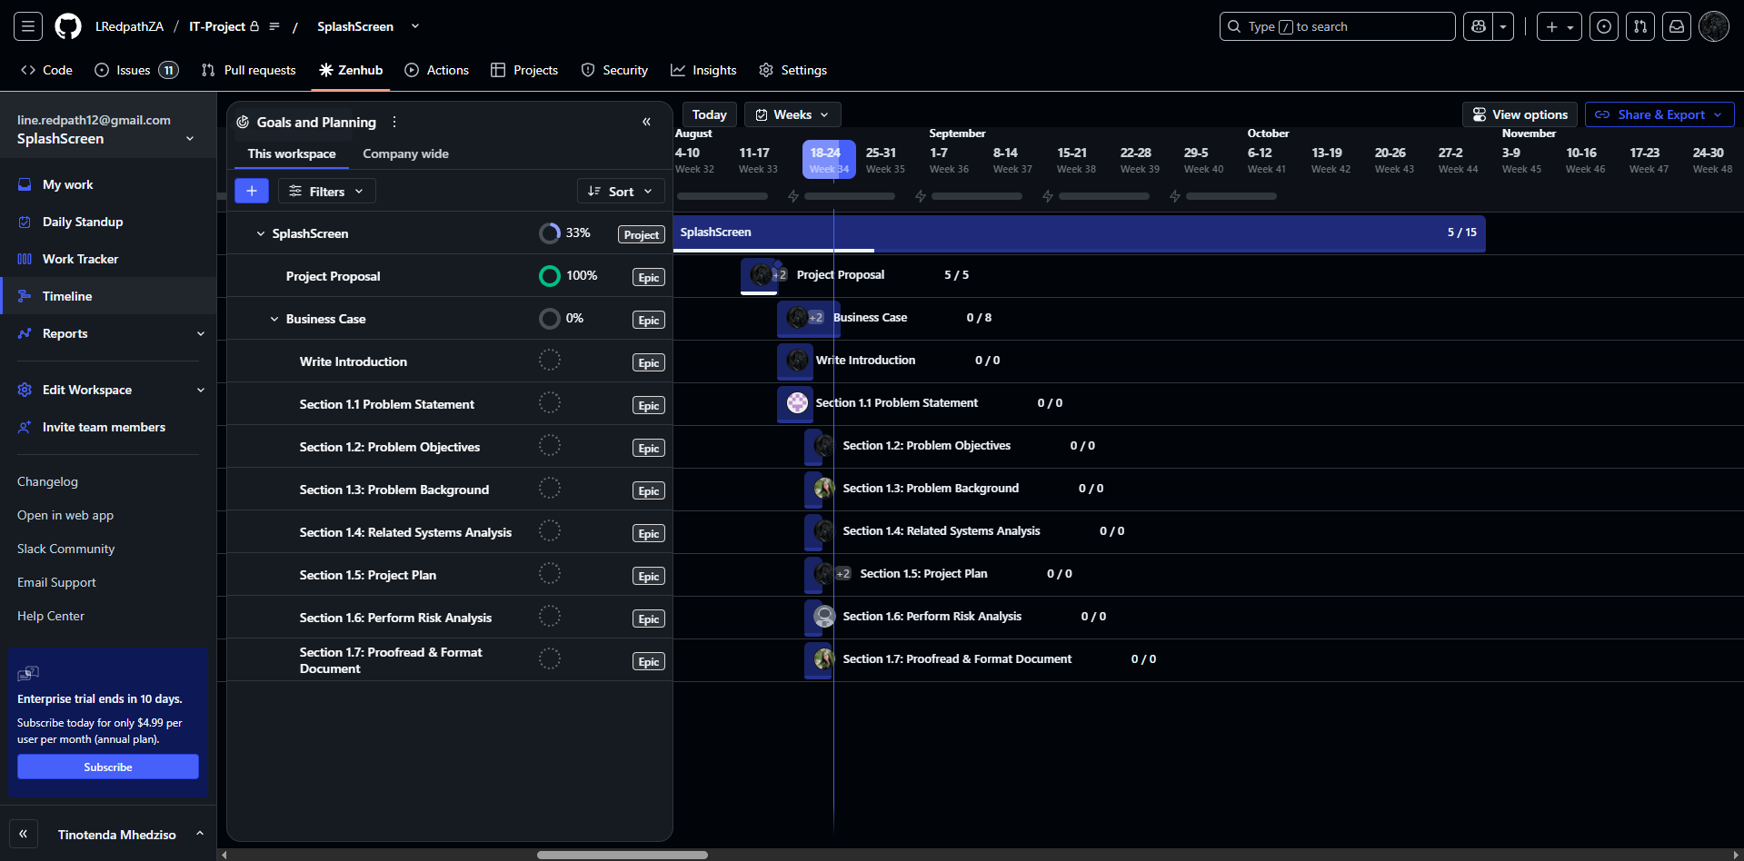

Figure 4.1

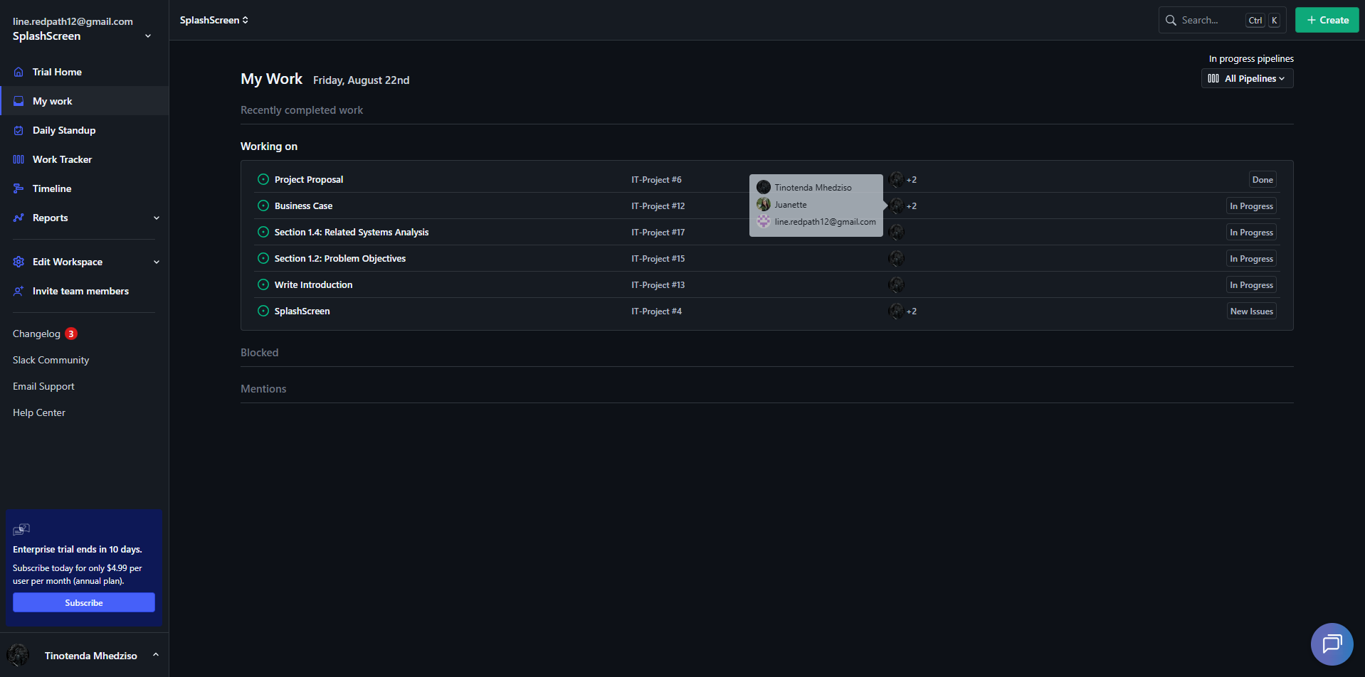

Figure 4.2

1.6 Risk Analysis

Risk: Leaking of Customer Data
Loss of customer data, like their address, password, or contact details.
This could lead to identity theft, reputational damage, and loss of trust.
Category: Avoidable Risk
Treatment: To implement encryption for sensitive data like password hashing or use of SSL/TLS. Applying role-based access control and conduct regular security checks.

Risk: Customer Forgetting Username/Password
If a user forgets their password or username, it could lock them out of their account.
Category: Minimizable Risk
Treatment: Setting up a secure password reset system (forgot password) via email or SMS to allow users to change their password.

Risk: Customer does not Know How to Work Through the Application
This could frustrate users and reduce adoption of the system.
Category: Acceptable/Minimizable Risk
Treatment: Providing guidance, tooltips, hints and user-friendly navigation.

Risk: Client (Reference Business) Withdrawal
If the business no longer wishes to participate, the app/project could lose a real-world reference.
Category: Transferable Risk
Treatment: By transferring the risk by making sure the system can still function as a generic pool services platform even without the specific client’s branding.
By giving other businesses, the opportunity to advertise their services and products via the app.

Risk: Team Member Illness or Unavailability
Tasks may be delayed if one member cannot work, especially if they handle a critical component for example the database or UI.
Category: Minimizable Risk
Treatment: By sharing knowledge among team members and agreeing on contingency roles so that another member will be able to temporarily take over.

Risk: Data Loss or System Crash
The loss of project files, database designs, or code progress could cause severe delays in the project.
Category: Avoidable Risk
Treatment: Using version control like Github and keeping cloud backups (Google Drive/OneDrive) as well as a local backup.

Risk: Possible Payment Problems
A payment gateway for SplashScreen presents a high risk due to the handling of sensitive financial data, which could lead to fraudulent transactions, stolen banking details, and non-compliance with data protection regulations.

Category: Transferable Risk

Treatment: We will avoid this risk entirely by not integrating a payment gateway into the SplashScreen app. Our individual users will pay the respective business directly using their preferred method, such as an EFT or a direct bank transfer. The business can then use our system to confirm the acceptance of the service request after payment has been received and processed through their own existing channels.

1.7 Annexure

Figure 1.1: A screenshot of the Orenda app’s home screen,
showing its primary water chemistry calculator for professionals……………………………………6.

Figure 1.2: A walkthrough screen in the Orenda app that
guides new users on how to use the chemical calculator and
understand water balance………………………………………………………………………………………………6.

Figure 1.3: An example of a product page within the
Orenda app, illustrating the platform's exclusive focus on
its own chemical product line…………………………………………………………………………………………6.

Figure 2.1: A view of the Pool Chemical Calculator’s
multi-pool management system, which allows users to
track different parameters for multiple properties…………………………………………………………8.

Figure 2.2: The event creation interface within the
Pool Chemical Calculator app, demonstrating how
users can schedule and create maintenance tasks………………………………………………………….8.

Figure 2.3: A view of a pool's calendar dashboard in the
Pool Chemical Calculator app, showing completed and
upcoming maintenance tasks…………………………………………………………………………………………8.

Figure 3.1: A screenshot of the Pool Math app's central card
stack, which provides a simple and direct way to access
various chemical calculation tools………………………………………………………………………………….9.

Figure 3.2: A view of the Pool Math app's test results
screen, showing how users can input readings to receive
immediate dosing instructions……………………………………………………………………………………….9.

Figure 3.3: The Pool Math app's primary chemical
calculator interface, highlighting its clean, focused design
for efficient water chemistry management…………………………………………………………………...9.

Figure 4.1: The ZenHub timeline feature showing
the planned workflow with task durations and dependencies……………………………………….14.

Figure 4.2: This ZenHub board provides a visual
overview of task assignments and progress for each
team member within a given sprint……………………………………………………………………………….14.

1.8 References
bigEE. (2015). Energy efficient swimming pool pumps . Retrieved from Wuppertal Institute for Climate, Environment and Energy: https://bigee.net/media/filer_public/2015/07/23/bigee_south_africa_poolpumps_20150723.pdf
CDC. (2024, May 10). Home Pool and Hot Tub Water Treament and Testing. Retrieved from U.S. Centers For Disease Control And Prevention: https://www.cdc.gov/healthy-swimming/about/home-pool-and-hot-tub-water-treatment-and-testing.html
Department of Water and Sanitation. (2023). National State of Water Report. Retrieved from https://www.dws.gov.za/Projects/National%20State%20of%20Water%20Report/Documents/National%20State%20of%20Water%20Report%202023_FinalVer3.0.pdf?utm_source=chatgpt.com
Du Plessis, J., & Jacobs, H. E. (2015). SciELO South Africa. Retrieved from Mitigating the impact of swimming pools on domestic water demand.: https://www.scielo.org.za/scielo.php?pid=S1816-79502015000200010&script=sci_arttext&utm_source=chatgpt.com
Econsultancy. (2022). HTH South African swimming pool care campaign case study. Retrieved from Econsultancy: https://econsultancy.com/case-studies/view/hth-south-african-swimming/
Lee, S., & Kim, H. (2019). Digital marketplaces and service centralizatio: Efficiency and consumer satisfaction trust. Journal of Business Research, 98, 102-111.
Musango, J. K., & Peter, C. (2012). Swimming pools and intra-city climates: influences on residential water consumption in Cape Town. Retrieved from SciELO South Africa: https://www.scielo.org.za/scielo.php?pid=S1816-79502012000100016&script=sci_arttext&utm_source=chatgpt.com
Patel, A., Mehta, R., & Sharma, S. (2021). Market consolidation and customer trust. Journal of Retailing and Consumer Services, 60, 102-111.
Queensland Government. (2019, December). Water quality guidelines for public aquatic facilities. Retrieved from Queensland Health: https://www.health.qld.gov.au/__data/assets/pdf_file/0021/444612/water-quality-guidelines.pdf?utm
Savelli. (2023, April 11). Wealthy residents' pools and gardens are driving water crises. Retrieved from The Washington Post: https://www.washingtonpost.com/climate-environment/2023/04/11/water-crisis-swimming-pool-cape-town/ The Washington Post
Wold Bank Group. (2021). Climatology. Retrieved from Climate Change Knowledge Portal: https://climateknowledgeportal.worldbank.org/country/south-africa/climate-data-historical

